**1.Main Menu-**Displays the main 3 operations

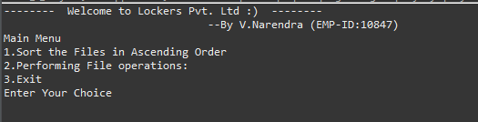

**2.Main Menu-**If we select First sorting operation since there are no elements in arraylist it will show a message that the there are no files in the list

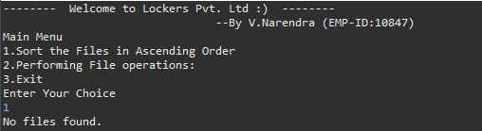

**3.Main Menu-** If user enter the 2nd option it will redirect to the file operations menu which has 4 features

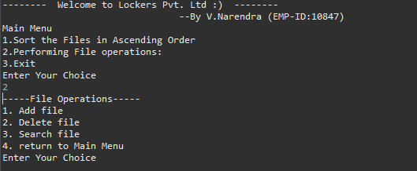

**4.File Operations Menu-** First option is to add files in to the list after selecting the first option user has to enter the Name of the file with extension the file will be added to the list

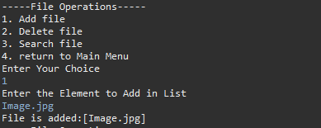

**5. File Operations Menu-Adding multiple files in the list**

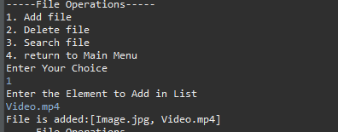

**6. File Operations Menu**

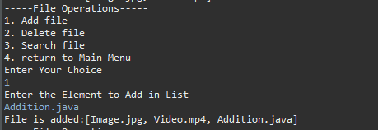

**7. File Operations Menu-Adding Result.csv file**

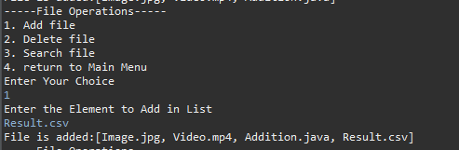

**8. File Operations Menu-Remove file—**By performing delete operation we have deleted Result.csv file from the list

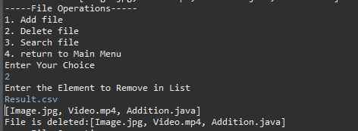

**9. File Operations Menu-Search operation—**By performing search operation we have searched the list for Video.mp4 file

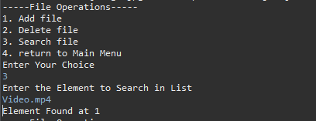

**10. File Operations Menu—Invalid Input—**If a user enters the input which is not defined the user will get a message like Invalid Input

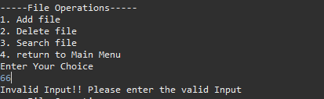

**11. File Operations Menu__return to Main Menu –** If we select 4th operation we will return to the Main menu like below

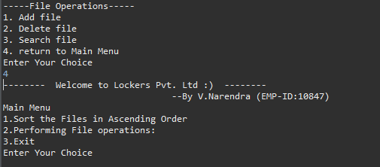

**12.Main Menu—Sorting—**Elements are sorted in the ascending order

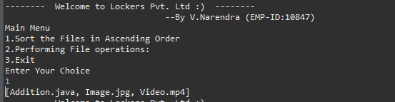

**13.Main Menu—Exit-** For Exiting the project user has the enter 3

